What this chapter does.
This chapter provides standards and guidelines for building design of commercial business developments. Although these standards are not required for industrial parks, warehouses, or large corporate office or campus developments, they are highly encouraged.

Purpose.
The purpose of this chapter is to provide standards and guidelines to enhance the visual quality of
Development, to help create developments that encourage pedestrian activity, to promote buildings of
lasting architecture and aesthetic appeal.

1. All commercial buildings shall avoid large panelized products or featureless surfaces.
Commercial buildings shall utilize an appropriate mixture of building materials on all sides, including
Brick, rock, fiber/cement siding, wood, glass, stucco, and colored architectural CMU (concrete
masonry unit). Stucco may not be used on more than 50 percent of a building. Metal plain CMU may be used as accents only.

A. Building Materials. Buildings should incorporate materials used throughout the city and be similar in
character and architectural theme as significant neighboring structures.
Architectural detailing and mixture of materials must be used on all sides – especially all street-facing sides.
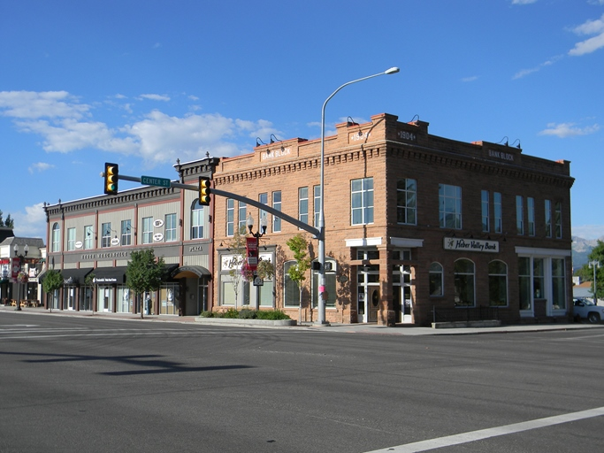

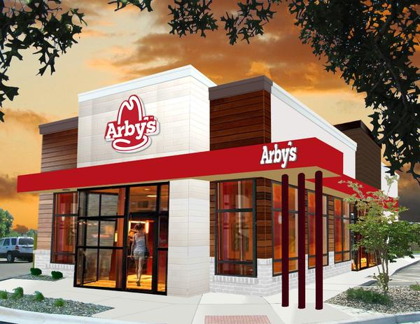
B. Building Color. A wide palette of colors is recommended, excluding any neon, ultra-bright, or
reflective colors. A building’s color palette should be similar to that of significant neighboring structures.
Franchise colors and elements may be incorporated, but shall not overpower the architectural form/theme of the building and/or development.
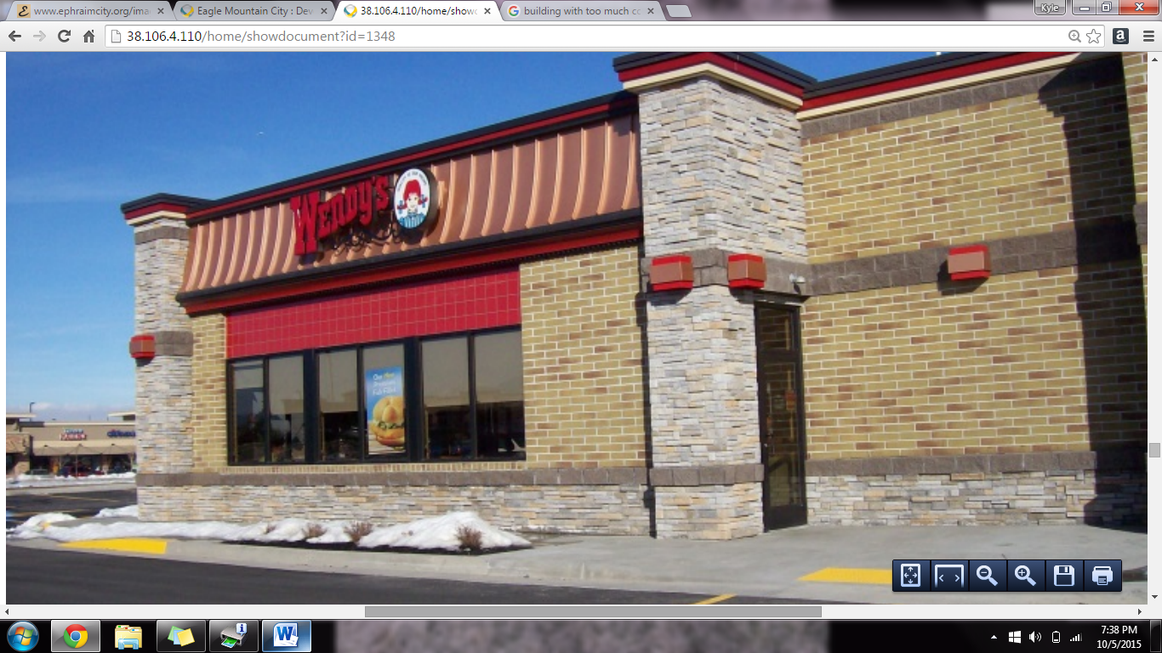
Varied materials: brick, stone, decorative CMU, and even tile and metal – identifiable franchise
elements.

Inappropriate: bright colors and creative architecture overpower the building form and clash with
Architecture and theming of neighboring buildings and community.
